Drafting the Flag
Nate Heiss
In Invasion Block Draft, only one thing is certain: there are no rules. Anyone can switch into any color at any time and justify it. Five color decks have more supporters than ever. I am not talking about Five-Color Green, either. With so many gold cards to choose from, no two drafts show a similar pattern. Most people just stick to their guns and draft what they know in order to survive the chaos. They formulate a plan and draft accordingly. This is a good thing. In Invasion Block draft, a good plan is like a good lifeboat on a sinking ship.

Drafting on the fly is a good strategy for some draft formats, making sure to read people's picks and what colors they are taking, then drafting accordingly. Invasion Block Draft is not one of those formats, unless you have evolved the ability to utilize your brain like a 2 GHz compiling program. It is just too much information to process in the time span that is allotted for picks. You need to have a plan or you'll freeze up like Windows 98 on 16 Megs of RAM.
I have come up with a plan for my own drafts that makes sense. Drafting the Flag...the U.S. Flag, that is. Good old red, white, and blue... plus a few extra colors for bombs. I like to draft what is being labeled a wedge deck. A wedge deck uses two allied colors and the color that opposes them both, forming a wedge (triangle) in the color wheel that can be found on the back of any Magic card. I feel that wedge decks give the most versatility and power in Invasion block, and they pay off big time when the Apocalypse pack rolls around. Here is my draft plan in order to draft the five-color Flag.

Invasion
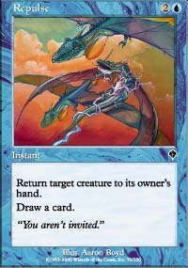
Invasion is the first pack opened. This set is the largest, so plans involving drafting one particular card (like Armadillo Cloak or Agonizing Demise) are poor because the chance of finding that one card is not good. Invasion promotes allied color strategies. All these factors are a strength in a wedge plan. You have the ability to pick from three colors right from the outset and you have the ability to pick up blue-white gold cards. Take Dream Thrush slightly higher than normal since the Flag is meant to have five-color capabilities, allowing you to play a handful off-color bombs (or kickers). Because of that, Armadillo Cloak, Probe, and Agonizing Demise will all fit into your deck after the draft, even though you are not in black or green.

Planeshift
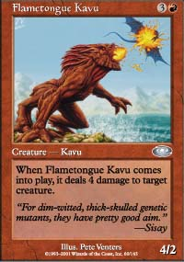
Planeshift is the second pack opened. Use the same strategy, making sure not to overdraft the off-color cards. There are numerous bombs in red alongside some flyers and tricks in white that should be relatively easy to pick up. The land-changing Kavu and Sea Snidd, both of which are late picks, work well in the Flag due to their mana fixing qualities.

Apocalypse
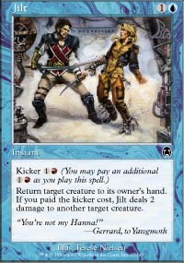
Apocalypse is the last pack. Fortunately, it is the pack that makes the Flag so powerful. Drafting the Flag lets you put many of the very powerful commons into your deck, such as Jilt, Quicksilver Dagger, Coalition Honor Guard, Goblin Legionnaire, and Razorfin Hunter. I especially like the Ceta, Raka, and Dega Disciples. The +2/+0 ability is extremely powerful with all the flyers that this deck usually has. You can usually make yourself a swamp in order to use Dega Disciples's -2/-0 ability as well. The Helionaut and Reef Shaman give you one last chance to pick up mana fixers (with the added bonus of flying in Helionaut's case, which is important with the Disciples) If you already have a bunch of mana fixers (3 or 4), this is not very crucial. If none of these cards are available to you, there is always Manacles of Decay and Standard Bearer, both of which are quality picks.
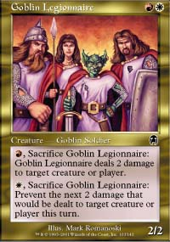
In review, drafting the Flag lets you be flexible with your picks. On the first two packs, pick up bombs and blue-white staples, in the last pack pick up most of the meaty part of your deck, defined by Flagbearers, Disciples, and last-ditch mana fixers. Your deck will play like Aggro-control, dropping early Disciples, but not winning until much later with pumped flyers. The Flag only has one weakness: its 2-drop slot. The only cards that really fit into the two mana slot are the Standard Bearer, Worldly Counsel, Dream Thrush, Meddling Mage, Galina's Knight, Razorfin Hunter, and Goblin Legionnaire (the latter two will most likely not come out on turn two anyhow because of the red in their casting cost). Having a mana curve is always a good thing, but it is not vital to the success of this deck. The last thing to remember about drafting the five-color Flag is that Domain cards are extra powerful. Cards like Worldly Counsel, Tribal Flames, and Exotic Curse become better due to the land-changing ability that some of your creatures are bound to have.
Blue-white-red has never been more fun to play. The amount of flexibility you get out of this deck is really amazing. It allows you to take whatever you want and still end up with a good deck. The deck generates situations where the Disciples are insane. The whole concept is just really complimentary to itself... that's what I like to see in a draft strategy. So if you find yourself stranded in the middle of a draft and things just aren't going your way... get on the lifeboat and draft the Flag.
If you have any questions or comments about this strategy, feel free to email me at nateheiss@yahoo.com.

